CHAPTER 8
Microbes in Human Welfare
• Microbes in Human Welfare

Ch 8 | MICROBES IN HUMAN WELFARE - Chapter Opener

Chapter contents (as printed on the opener page): 8.1 Microbes in Household Products; 8.2 Microbes in Industrial Products; 8.3 Microbes in Sewage Treatment; 8.4 Microbes in Production of Biogas; 8.5 Microbes as Biocontrol Agents; 8.6 Microbes as Biofertilisers.
Besides macroscopic plants and animals, microbes are the major components of biological systems on this earth. You have studied about the diversity of living organisms in Class XI: recall which Kingdoms among the living organisms contain micro-organisms, and which of those groups are only microscopic.
Microbes are present everywhere - in soil, water, air, inside our bodies and that of other animals and plants. They are present even at sites where no other life-form could possibly exist:
• deep inside the geysers (thermal vents), where the temperature may be as high as 100 C;
• deep in the soil;
• under the layers of snow several metres thick;
• in highly acidic environments.
• Microbes are diverse - protozoa, bacteria, fungi and microscopic animal and plant viruses, viroids and also prions, that are proteinacious infectious agents.
Some of the microbes are shown in Figures 8.1 and 8.2, embedded below.
Microbes like bacteria and many fungi can be grown on nutritive media to form colonies (Figure 8.3), that can be seen with the naked eyes. Such cultures are useful in studies on micro-organisms.
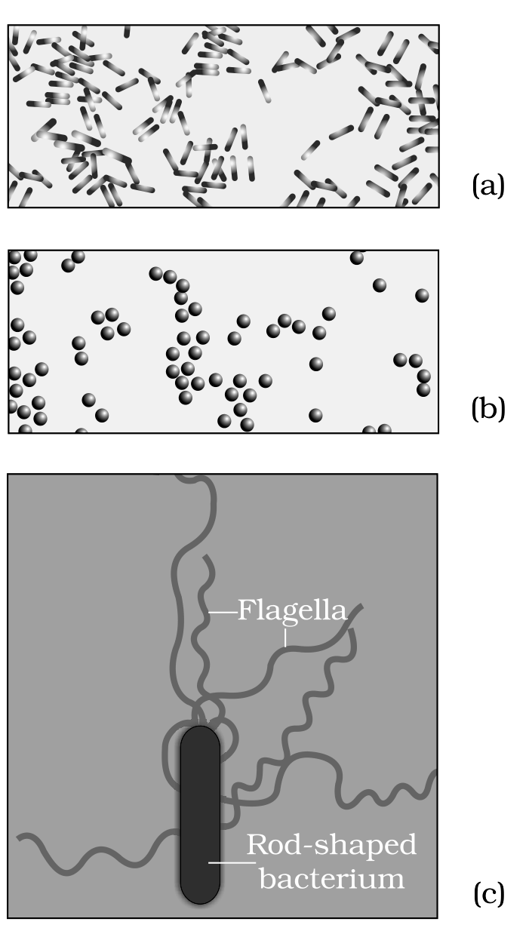
Fig. 8.1 - Bacteria: (a) Rod-shaped, magnified 1500X; (b) Spherical shaped, magnified 1500X; (c) A rod-shaped bacterium showing flagella, magnified 50,000X.
Labels on Figure 8.1: panel (c) is a Rod-shaped bacterium whose Flagella are marked - the long whip-like appendages seen at 50,000X but invisible in the 1500X views of panels (a) and (b).
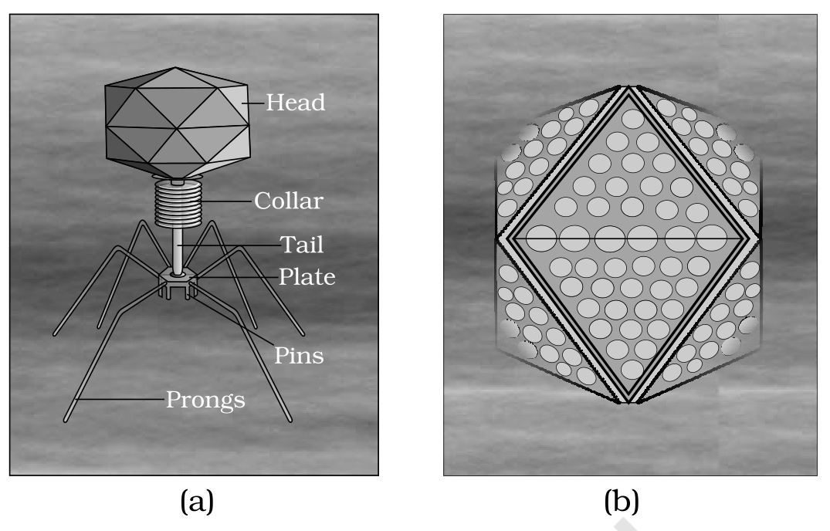
Fig. 8.2 (a), (b) - Viruses: (a) A bacteriophage; (b) Adenovirus which causes respiratory infections.
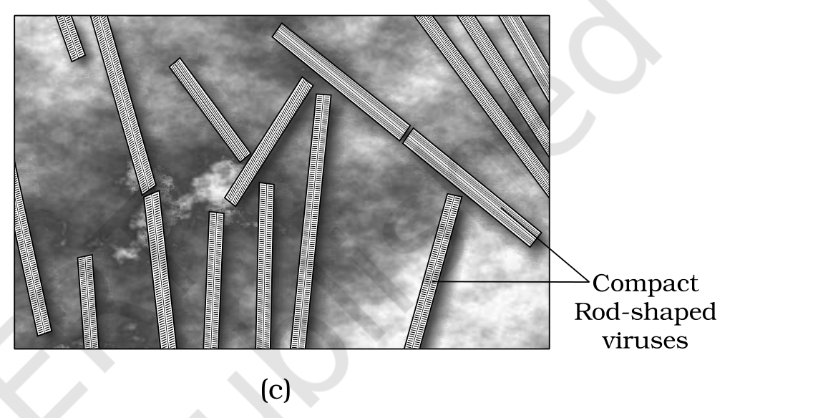
Fig. 8.2 (c) - Rod-shaped Tobacco Mosaic Virus (TMV). Magnified about 1,00,000-1,50,000X.
Labels on Figure 8.2: the bacteriophage of panel (a) is drawn part by part - Head, Collar, Tail, Plate, Pins and Prongs - so the phage reads as a head-plus-tail particle that anchors to a bacterium by its plate, pins and prongs. Panel (b) is the Adenovirus which causes respiratory infections. Panel (c) shows Compact Rod-shaped viruses, the Tobacco Mosaic Virus (TMV) particles, magnified about 1,00,000-1,50,000X.
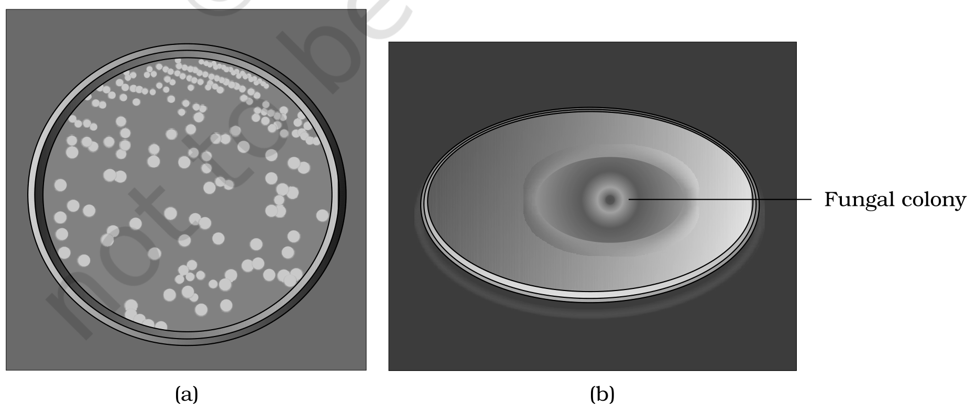
Fig. 8.3 - (a) Colonies of bacteria growing in a petri dish; (b) Fungal colony growing in a petri dish.
Labels on Figure 8.3: panel (a) carries the bacterial colonies in a petri dish and panel (b) is marked Fungal colony - both are growths on nutritive media large enough to be seen with the naked eye.
In chapter 7, you have read that microbes cause a large number of diseases in human beings. They also cause diseases in animals and plants. But this should not make you think that all microbes are harmful; several microbes are useful to man in diverse ways. Some of the most important contributions of microbes to human welfare are discussed in this chapter.
8.1 | MICROBES IN HOUSEHOLD PRODUCTS

We use microbes or products derived from them everyday. A common example is the production of curd from milk.
• Micro-organisms such as Lactobacillus and others, commonly called lactic acid bacteria (LAB), grow in milk and convert it to curd.
1 | During growth, the LAB produce acids that coagulate and partially digest the milk proteins.
2 | A small amount of curd added to fresh milk as inoculum or starter contains millions of LAB.
3 | At suitable temperatures these multiply, thus converting milk to curd.
4 | Curd also has improved nutritional quality, because the LAB increase vitamin B12.

In our stomach too, the LAB play a very beneficial role in checking disease-causing microbes.
The dough used for making foods such as dosa and idli is also fermented by bacteria. The puffed-up appearance of dough is due to the production of CO2 gas. Two questions worth answering from Class XI: which metabolic pathway is taking place resulting in the formation of CO2, and where do the bacteria for these fermentations come from?
Similarly, the dough used for making bread is fermented using baker's yeast (Saccharomyces cerevisiae). A number of traditional drinks and foods are also made by fermentation by microbes: 'Toddy', a traditional drink of some parts of southern India, is made by fermenting sap from palms, and microbes are also used to ferment fish, soyabean and bamboo-shoots to make foods.
Cheese is one of the oldest food items in which microbes were used. Different varieties of cheese are known by their characteristic texture, flavour and taste, the specificity coming from the microbes used.
Household product | Microbe used | What the microbe does
Curd (from milk) | Lactobacillus and other lactic acid bacteria (LAB) | Produce acids that coagulate and partially digest milk proteins; increase vitamin B12
Dosa / idli dough | Bacteria | Fermentation; the CO2 produced puffs up the dough
Bread dough | Baker's yeast, Saccharomyces cerevisiae | Fermentation of the dough
'Toddy' (southern India) | Microbes of the sap | Ferment sap from palms into a traditional drink
Fermented fish, soyabean, bamboo-shoots | Microbes | Fermentation into foods
'Swiss cheese' - large holes | Bacterium Propionibacterium sharmanii | Produces a large amount of CO2, which makes the large holes
'Roquefort cheese' | A specific fungi grown on them | Ripens the cheese and gives it a particular flavour

[NOTE] Beyond the body text - for exercise Q4. The chapter's own fermented-food examples cover wheat (bread dough, baker's yeast) and rice (idli and dosa dough), but name no Bengal gram dish. The mapping the exercise expects is: wheat gives bread, rice gives idli and dosa, and Bengal gram gives dhokla. Only the first two are NCERT body sentences.

8.2 | MICROBES IN INDUSTRIAL PRODUCTS

Even in industry, microbes are used to synthesise a number of products valuable to human beings. Beverages and antibiotics are some examples.
• Production on an industrial scale requires growing microbes in very large vessels called fermentors (Figure 8.4).
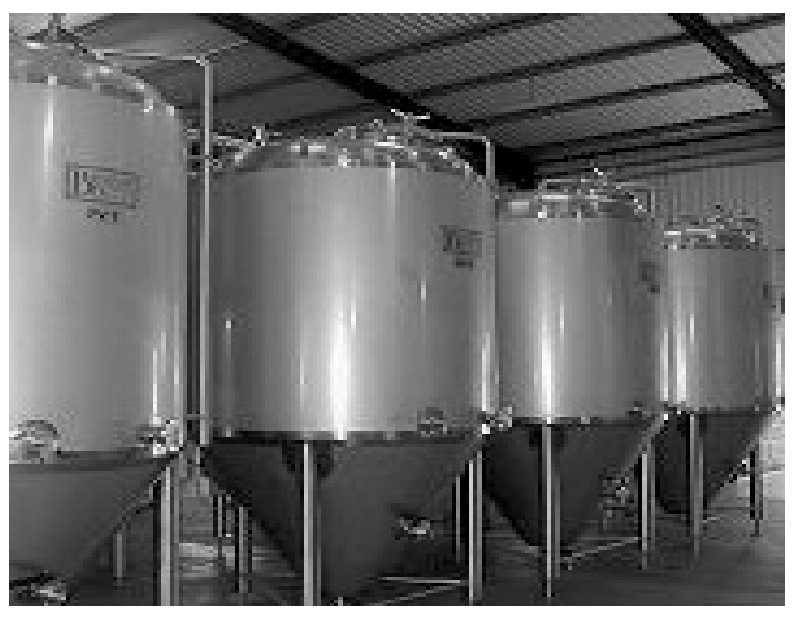
Fig. 8.4 - Fermentors. The very large vessels in which microbes are grown for industrial-scale production; the plate carries no labels of its own.
8.2.1 | Fermented Beverages

Microbes, especially yeasts, have been used from time immemorial for the production of beverages like wine, beer, whisky, brandy or rum. For this purpose the same yeast Saccharomyces cerevisiae used for bread-making, and commonly called brewer's yeast, is used for fermenting malted cereals and fruit juices, to produce ethanol. Recollect the metabolic reactions which result in the production of ethanol by yeast.
Depending on the type of the raw material used for fermentation and the type of processing (with or without distillation), different types of alcoholic drinks are obtained.
Processing | Drinks obtained
Without distillation | Wine and beer
By distillation of the fermented broth | Whisky, brandy and rum

The photograph of a fermentation plant is shown in Figure 8.5.
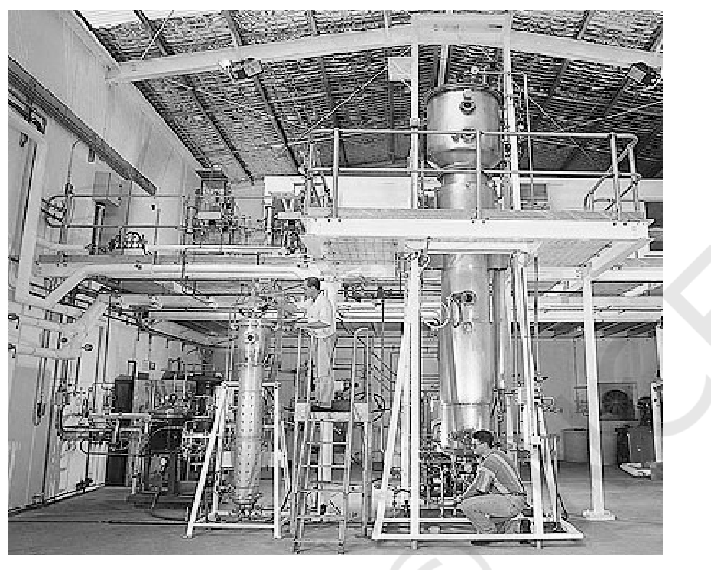
Fig. 8.5 - Fermentation Plant. An industrial fermentation plant photographed whole; the plate carries no labels of its own.
8.2.2 | Antibiotics

Antibiotics produced by microbes are regarded as one of the most significant discoveries of the twentieth century and have greatly contributed towards the welfare of the human society.
Anti is a Greek word that means 'against', and bio means 'life'; together they mean 'against life' (in the context of disease causing organisms) - whereas with reference to human beings, they are 'pro life' and not against.
• Antibiotics are chemical substances, which are produced by some microbes and can kill or retard the growth of other (disease-causing) microbes.
You are familiar with the commonly used antibiotic Penicillin. Penicillin was the first antibiotic to be discovered, and it was a chance discovery:
1 | Alexander Fleming, while working on Staphylococci bacteria, once observed a mould growing in one of his unwashed culture plates, around which Staphylococci could not grow.
2 | He found out that it was due to a chemical produced by the mould, and he named it Penicillin after the mould Penicillium notatum.
3 | However, its full potential as an effective antibiotic was established much later by Ernest Chain and Howard Florey.
4 | This antibiotic was extensively used to treat American soldiers wounded in World War II.
5 | Fleming, Chain and Florey were awarded the Nobel Prize in 1945, for this discovery.

After Penicillin, other antibiotics were also purified from other microbes - it is worth naming some other antibiotics and finding out their sources. Antibiotics have greatly improved our capacity to treat deadly diseases such as plague, whooping cough (kali khansi), diphtheria (gal ghotu) and leprosy (kusht rog), which used to kill millions all over the globe. Today, we cannot imagine a world without antibiotics.
Stated in the chapter's own summary: antibiotics have played a major role in controlling infectious diseases like diphtheria, whooping cough and pneumonia.
[NOTE] Beyond the body text - for exercise Q6. The question asks for two fungal species used to produce antibiotics, but the body names only one fungus, Penicillium notatum (Fleming's mould). The second conventionally accepted answer is Penicillium chrysogenum, the species used for commercial penicillin production. It is not an NCERT sentence from this chapter.

8.2.3 | Chemicals, Enzymes and other Bioactive Molecules

Microbes are also used for commercial and industrial production of certain chemicals like organic acids, alcohols and enzymes.
Product | Microbe | Group
Citric acid | Aspergillus niger | a fungus
Acetic acid | Acetobacter aceti | a bacterium
Butyric acid | Clostridium butylicum | a bacterium
Lactic acid | Lactobacillus | a bacterium
Ethanol (commercial production) | Yeast (Saccharomyces cerevisiae) | a yeast

Microbes are also used for production of enzymes. Lipases are used in detergent formulations and are helpful in removing oily stains from the laundry. Bottled fruit juices bought from the market are clearer as compared to those made at home, because the bottled juices are clarified by the use of pectinases and proteases.
Bioactive molecule | Produced by | Use / mechanism
Streptokinase (modified by genetic engineering) | the bacterium Streptococcus | 'Clot buster' - removes clots from the blood vessels of patients who have undergone myocardial infarction leading to heart attack
Cyclosporin A | the fungus Trichoderma polysporum | Immunosuppressive agent in organ-transplant patients
Statins | the yeast Monascus purpureus | Commercialised as blood-cholesterol lowering agents; act by competitively inhibiting the enzyme responsible for synthesis of cholesterol

[NOTE] Beyond the body text - for exercise Q13(a). The term single cell protein (SCP) appears nowhere in this chapter's body. SCP is microbial biomass - the cells of microbes such as Spirulina grown in bulk - used as protein-rich food or animal feed. This definition is exercise support, not an NCERT sentence from this chapter.

8.3 | MICROBES IN SEWAGE TREATMENT

Large quantities of waste water are generated everyday in cities and towns. A major component of this waste water is human excreta.
• This municipal waste-water is also called sewage.
Sewage contains large amounts of organic matter and microbes. Many of which are pathogenic. It is worth wondering where this huge quantity of sewage or urban waste water is disposed off daily: it cannot be discharged into natural water bodies like rivers and streams directly - and you can understand why, because that organic matter and those pathogens would go straight into the river. Before disposal, hence, sewage is treated in sewage treatment plants (STPs) to make it less polluting.
Treatment of waste water is done by the heterotrophic microbes naturally present in the sewage. This treatment is carried out in two stages.
8.3a | Primary treatment

These treatment steps basically involve the physical removal of particles - large and small - from the sewage through filtration and sedimentation. These are removed in stages:
1 | Initially, floating debris is removed by sequential filtration.
2 | Then the grit (soil and small pebbles) is removed by sedimentation.
3 | All solids that settle form the primary sludge, and the supernatant forms the effluent.
4 | The effluent from the primary settling tank is taken for secondary treatment.

8.3b | Secondary treatment or Biological treatment

The primary effluent is passed into large aeration tanks (Figure 8.6) where it is constantly agitated mechanically and air is pumped into it. This allows vigorous growth of useful aerobic microbes into flocs - masses of bacteria associated with fungal filaments to form mesh like structures. While growing, these microbes consume the major part of the organic matter in the effluent. This significantly reduces the BOD (biochemical oxygen demand) of the effluent.
• BOD refers to the amount of the oxygen that would be consumed if all the organic matter in one liter of water were oxidised by bacteria.
• The sewage water is treated till the BOD is reduced.
• The BOD test measures the rate of uptake of oxygen by micro-organisms in a sample of water and thus, indirectly, BOD is a measure of the organic matter present in the water.
• The greater the BOD of waste water, more is its polluting potential.
1 | Once the BOD of sewage or waste water is reduced significantly, the effluent is passed into a settling tank where the bacterial 'flocs' are allowed to sediment.
2 | This sediment is called activated sludge.
3 | A small part of the activated sludge is pumped back into the aeration tank to serve as the inoculum.
4 | The remaining major part of the sludge is pumped into large tanks called anaerobic sludge digesters.
5 | Here, other kinds of bacteria, which grow anaerobically, digest the bacteria and the fungi in the sludge.
6 | During this digestion, bacteria produce a mixture of gases such as methane, hydrogen sulphide and carbon dioxide. These gases form biogas and can be used as source of energy as it is inflammable.
7 | The effluent from the secondary treatment plant is generally released into natural water bodies like rivers and streams.

Stated in the chapter's own summary: this treatment of sewage by the process of activated sludge formation also helps in recycling of water in nature.
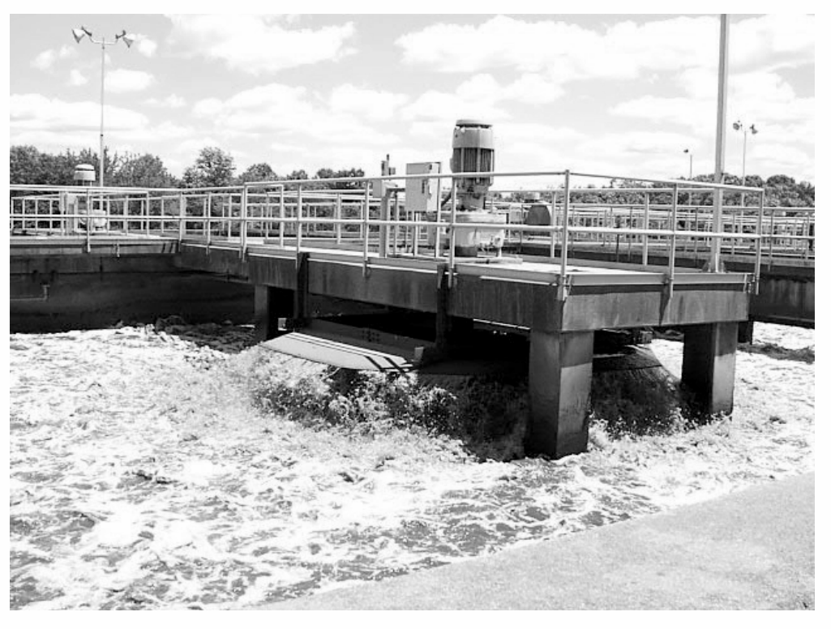
Fig. 8.6 - Secondary treatment. The large aeration tank of the biological stage, photographed in operation; the plate carries no labels of its own.
An aerial view of such a plant is shown in Figure 8.7.
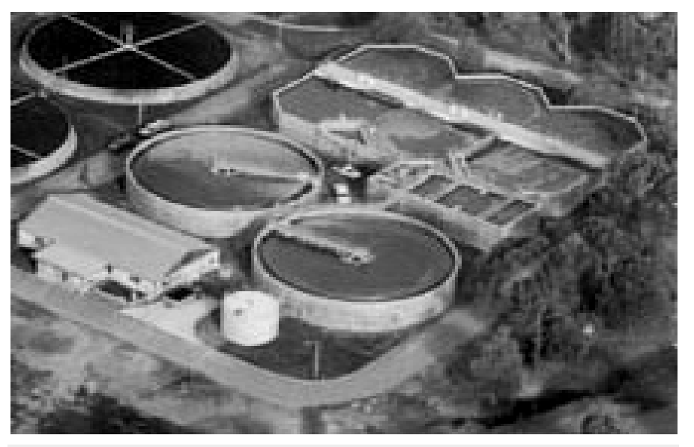
Fig. 8.7 - An aerial view of a sewage plant. The tanks of a whole sewage treatment plant seen from above; the plate carries no labels of its own.
Microbes thus play a major role in treating millions of gallons of waste water everyday across the globe. This methodology has been practiced for more than a century now, in almost all parts of the world. Till date, no man-made technology has been able to rival the microbial treatment of sewage.
However, due to increasing urbanisation, sewage is being produced in much larger quantities than ever before, and the number of sewage treatment plants has not increased enough to treat such large quantities. So the untreated sewage is often discharged directly into rivers, leading to their pollution and increase in water-borne diseases. The Ministry of Environment and Forests has initiated the Ganga Action Plan and Yamuna Action Plan to save these major rivers of our country from pollution; under these plans, it is proposed to build a large number of sewage treatment plants so that only treated sewage may be discharged in the rivers. A visit to a sewage treatment plant situated in any place near you would be a very interesting and educating experience.
[NOTE] Primary vs secondary treatment - the key difference (exercise Q8). Primary treatment is physical - filtration and sedimentation remove floating debris and grit, giving primary sludge plus the effluent. Secondary (biological) treatment is microbial - aerobic microbes growing as flocs consume the organic matter and reduce the BOD, and the sediment they form is the activated sludge.

8.4 | MICROBES IN PRODUCTION OF BIOGAS

• Biogas is a mixture of gases (containing predominantly methane) produced by the microbial activity and which may be used as fuel.
Microbes produce different types of gaseous end-products during growth and metabolism, and the type of the gas produced depends upon the microbes and the organic substrates they utilise. In the examples cited in relation to fermentation of dough, cheese making and production of beverages, the main gas produced was CO2. However, certain bacteria, which grow anaerobically on cellulosic material, produce large amount of methane along with CO2 and H2.
• These bacteria are collectively called methanogens, and one such common bacterium is Methanobacterium.
These bacteria are commonly found in the anaerobic sludge during sewage treatment.
These bacteria are also present in the rumen (a part of stomach) of cattle. A lot of cellulosic material present in the food of cattle is also present in the rumen, and in the rumen these bacteria help in the breakdown of cellulose and play an important role in the nutrition of cattle. (Worth asking: are we, human beings, able to digest the cellulose present in our foods?) Thus, the excreta (dung) of cattle, commonly called gobar, is rich in these bacteria, and dung can be used for generation of biogas, commonly called gobar gas.
1 | The biogas plant consists of a concrete tank (10-15 feet deep) in which bio-wastes are collected and a slurry of dung is fed.
2 | A floating cover is placed over the slurry, which keeps on rising as the gas is produced in the tank due to the microbial activity.
3 | The biogas plant has an outlet, which is connected to a pipe to supply biogas to nearby houses.
4 | The spent slurry is removed through another outlet and may be used as fertiliser.

Cattle dung is available in large quantities in rural areas where cattle are used for a variety of purposes, so biogas plants are more often built in rural areas. The biogas thus produced is used for cooking and lighting. The picture of a biogas plant is shown in Figure 8.8.
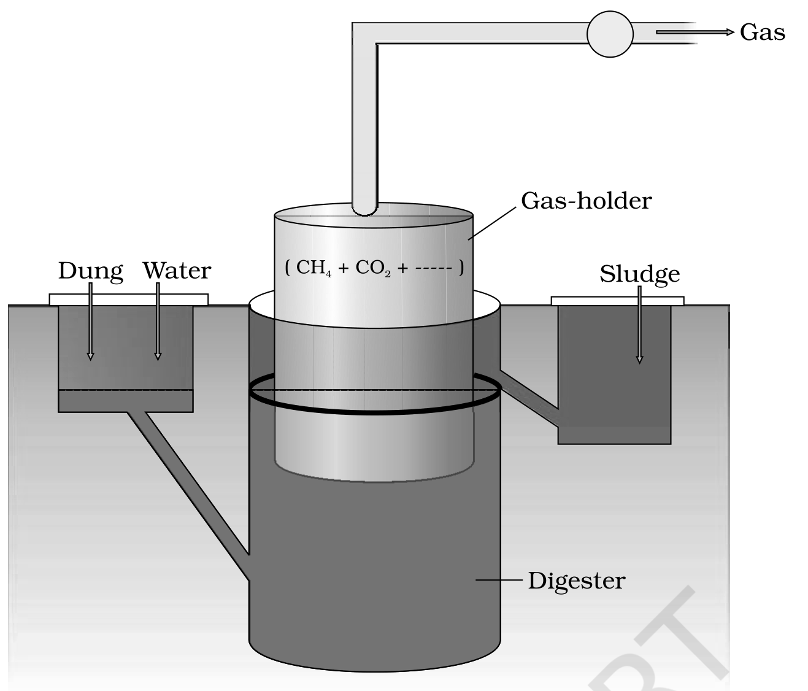
Fig. 8.8 - A typical biogas plant.
Labels on Figure 8.8: Dung and Water are mixed and fed as slurry into the Digester, the concrete tank 10-15 feet deep. The floating cover above it is the Gas-holder, which rises as gas collects. The Gas leaves by the outlet pipe and is a mixture of CH4 + CO2, and the spent Sludge is drawn off through the second outlet for use as fertiliser.
The technology of biogas production was developed in India mainly due to the efforts of the Indian Agricultural Research Institute (IARI) and the Khadi and Village Industries Commission (KVIC). If your school is situated in a village or near a village, it would be very interesting to enquire if there are any biogas plants nearby, visit the biogas plant and learn more about it from the people who are actually managing it.
8.5 | MICROBES AS BIOCONTROL AGENTS

• Biocontrol refers to the use of biological methods for controlling plant diseases and pests.
In modern society, these problems have been tackled increasingly by the use of chemicals - by use of insecticides and pesticides. These chemicals are toxic and extremely harmful, to human beings and animals alike, and have been polluting our environment (soil, ground water), fruits, vegetables and crop plants. Our soil is also polluted through our use of weedicides to remove weeds.
8.5a | Biological control of pests and diseases

In agriculture, there is a method of controlling pests that relies on natural predation rather than introduced chemicals.
• A key belief of the organic farmer is that biodiversity furthers health. The more variety a landscape has, the more sustainable it is.
• The organic farmer therefore works to create a system where the insects that are sometimes called pests are not eradicated, but instead are kept at manageable levels by a complex system of checks and balances within a living and vibrant ecosystem.
• Contrary to the 'conventional' farming practices, which often use chemical methods to kill both useful and harmful life forms indiscriminately, this is a holistic approach that seeks to develop an understanding of the webs of interaction between the myriad of organisms that constitute the field fauna and flora.
• The organic farmer holds the view that the eradication of the creatures that are often described as pests is not only possible, but also undesirable - for without them the beneficial predatory and parasitic insects which depend upon them as food or hosts would not be able to survive.
• Thus, the use of biocontrol measures will greatly reduce our dependence on toxic chemicals and pesticides.
• An important part of the biological farming approach is to become familiar with the various life forms that inhabit the field, predators as well as pests, and also their life cycles, patterns of feeding and the habitats that they prefer. This will help develop appropriate means of biocontrol.
Biocontrol agent | What it is | Target / effect
Ladybird - the very familiar beetle with red and black markings | A beetle | Useful to get rid of aphids
Dragonflies | Insects | Useful to get rid of mosquitoes
Bacillus thuringiensis (often written as Bt) | A bacterium - a microbial biocontrol agent that can be introduced | Controls butterfly caterpillars
Trichoderma | Free-living fungi that are very common in the root ecosystems | A biological control being developed for use in the treatment of plant disease; effective biocontrol agents of several plant pathogens
Baculoviruses, majority in the genus Nucleopolyhedrovirus | Pathogens that attack insects and other arthropods | Excellent candidates for species-specific, narrow spectrum insecticidal applications

How Bt works when it is applied:
1 | Bt is available in sachets as dried spores, which are mixed with water and sprayed onto vulnerable plants such as brassicas and fruit trees.
2 | The spores are eaten by the insect larvae.
3 | In the gut of the larvae, the toxin is released and the larvae get killed.
4 | The bacterial disease will kill the caterpillars, but leave other insects unharmed.

Because of the development of methods of genetic engineering in the last decade or so, scientists have introduced B. thuringiensis toxin genes into plants. Such plants are resistant to attack by insect pests. Bt-cotton is one such example, which is being cultivated in some states of our country - more about this in chapter 10.
Baculoviruses have been shown to have no negative impacts on plants, mammals, birds, fish or even on non-target insects. This is especially desirable when beneficial insects are being conserved to aid in an overall integrated pest management (IPM) programme, or when an ecologically sensitive area is being treated.
[MEMORY AID - not in NCERT] For the three microbial biocontrol agents, remember B-T-B: Bt the bacterium kills caterpillars, Trichoderma the fungus fights plant pathogens, and Baculovirus the virus is the narrow-spectrum insecticide. Bacterium, fungus, virus - in that order.

8.6 | MICROBES AS BIOFERTILISERS

With our present day life styles, environmental pollution is a major cause of concern. The use of the chemical fertilisers to meet the ever-increasing demand of agricultural produce has contributed significantly to this pollution. We have now realised that there are problems associated with the overuse of chemical fertilisers and there is a large pressure to switch to organic farming - the use of biofertilisers.
• Biofertilisers are organisms that enrich the nutrient quality of the soil. The main sources of biofertilisers are bacteria, fungi and cyanobacteria.
You have studied about the nodules on the roots of leguminous plants formed by the symbiotic association of Rhizobium. These bacteria fix atmospheric nitrogen into organic forms, which is used by the plant as nutrient. Other bacteria can fix atmospheric nitrogen while free-living in the soil (examples Azospirillum and Azotobacter), thus enriching the nitrogen content of the soil.
Fungi are also known to form symbiotic associations with plants (mycorrhiza), and many members of the genus Glomus form mycorrhiza. The fungal symbiont in these associations absorbs phosphorus from soil and passes it to the plant. Plants having such associations show other benefits also: resistance to root-borne pathogens, tolerance to salinity and drought, and an overall increase in plant growth and development. (Worth asking: what advantage does the fungus derive from this association?)
• Cyanobacteria are autotrophic microbes widely distributed in aquatic and terrestrial environments, many of which can fix atmospheric nitrogen, e.g. Anabaena, Nostoc, Oscillatoria, etc.
In paddy fields, cyanobacteria serve as an important biofertiliser. Blue green algae also add organic matter to the soil and increase its fertility.
Biofertiliser group | Examples | Nutrient benefit to the soil / plant
Symbiotic nitrogen-fixing bacteria | Rhizobium (root nodules of legumes) | Fix atmospheric nitrogen into organic forms used by the plant as nutrient
Free-living nitrogen-fixing bacteria | Azospirillum, Azotobacter | Enrich the nitrogen content of the soil
Mycorrhizal fungi | Genus Glomus | Absorb phosphorus from soil and pass it to the plant; also resistance to root-borne pathogens, tolerance to salinity and drought, overall increase in growth and development
Cyanobacteria (blue green algae) | Anabaena, Nostoc, Oscillatoria | Fix atmospheric nitrogen; important biofertiliser in paddy fields; add organic matter to the soil and increase its fertility

Currently, in our country, a number of biofertilisers are available commercially in the market and farmers use these regularly in their fields to replenish soil nutrients and to reduce dependence on chemical fertilisers.
[NOTE] Beyond the body text - for exercise Q13(b), the role of microbes in soil. Assembled only from facts already in this chapter: soil microbes fix atmospheric nitrogen (Rhizobium in root nodules; free-living Azospirillum and Azotobacter), mobilise phosphorus to the plant through mycorrhiza (Glomus), add organic matter and increase fertility (cyanobacteria and blue green algae), and - as the sewage sections show - decompose organic matter, because the heterotrophic microbes that treat sewage digest exactly the organic matter and the microbial sludge fed to them. The general decomposer role is not stated as such in this chapter's body.

Recap | QUICK RECAP

• Microbes are a very important component of life on earth, present everywhere including geysers at up to 100 C. Not all microbes are pathogenic; many are very useful to human beings, and we use microbes and microbially derived products almost every day.
• Curd: lactic acid bacteria (LAB) such as Lactobacillus grow in milk and convert it into curd, and raise vitamin B12.
• Dough: bread dough is fermented by the yeast Saccharomyces cerevisiae; idli and dosa are made from dough fermented by microbes, puffed up by CO2.
• Cheese: bacteria and fungi impart particular texture, taste and flavour - Propionibacterium sharmanii makes the holes of Swiss cheese, a fungus ripens Roquefort.
• Industry: microbes produce lactic acid, acetic acid and alcohol and other industrial products, in fermentors; beverages are wine and beer (no distillation) or whisky, brandy and rum (distillation).
• Antibiotics like penicillins, produced by useful microbes, are used to kill disease-causing harmful microbes, and have played a major role in controlling infectious diseases like diphtheria, whooping cough and pneumonia. Fleming, Chain and Florey: Nobel Prize, 1945.
• Bioactive molecules: streptokinase (clot buster), cyclosporin A (immunosuppressive), statins (cholesterol lowering); enzymes lipases, pectinases and proteases.
• Sewage: for more than a hundred years, microbes have been used to treat sewage (waste water) by the process of activated sludge formation, which helps in recycling of water in nature. Primary treatment is physical; secondary treatment is biological and reduces the BOD.
• Biogas: methanogens such as Methanobacterium produce methane (biogas) while degrading plant waste, in anaerobic sludge and in the rumen of cattle; biogas produced by microbes is used as a source of energy in rural areas, for cooking and lighting.
• Biocontrol: microbes can also be used to kill harmful pests - Bt, Trichoderma, baculoviruses - and these measures help us to avoid heavy use of toxic pesticides for controlling pests.
• Biofertilisers: there is a need these days to push for use of biofertilisers in place of chemical fertilisers - Rhizobium, Azospirillum, Azotobacter, mycorrhizal Glomus, and cyanobacteria in paddy fields.
• It is clear from the diverse uses human beings have put microbes to that they play an important role in the welfare of human society.
Appendix | TERMS USED IN THE EXERCISES

The chapter's EXERCISES lean on four items the body text never supplies; each is covered in a NOTE box at the point it belongs, and all four are collected here.
• Q4 - Bengal gram: wheat gives bread, rice gives idli and dosa, Bengal gram gives dhokla (see 8.1).
• Q6 - two fungal species for antibiotics: Penicillium notatum from the body text, plus Penicillium chrysogenum (see 8.2.2).
• Q13(a) - single cell protein (SCP): microbial biomass, e.g. Spirulina, used as protein-rich food or feed (see 8.2.3).
• Q13(b) - microbes in soil: nitrogen fixation, phosphorus mobilisation via mycorrhiza, addition of organic matter, and decomposition of organic matter (see 8.6).
Exercise Q11 data (reproduce these values exactly). Three water samples - river water, untreated sewage water and secondary effluent discharged from a sewage treatment plant - were subjected to the BOD test and labelled A, B and C, with the values recorded as follows:
Sample | BOD recorded | Which water it is, by BOD
A | 20mg/L | River water - low BOD, so least polluting potential
B | 8mg/L | Secondary effluent - lowest BOD, already treated
C | 400mg/L | Untreated sewage water - highest BOD, most polluting potential

[NOTE] The three waters named in Q11 are river water, untreated sewage water and secondary effluent, and the values given are 20mg/L, 8mg/L and 400mg/L, respectively, for samples A, B and C. Match them by the rule that the greater the BOD of waste water, the more is its polluting potential.

